# CS 255 Business Requirements Document Template

## System Components and Design

### Purpose

DriverPass is a company that wishes to fill the void in the market in regards to training students for their driving test. The purpose of this project is to build a system that will provide online classes, practice tests and on-the-road training to the customers of DriverPass (Stefanelli, 2022).

### System Background

The DriverPass system needs to be implemented in order for the owner, Liam, to offer his services as a business who trains drivers so they can pass their driving test (Stefanelli, 2022, p. 1). The system must allow customers to purchase packages for on-the-road and in-person training, as well as online courses in order pass their driving tests (Stefanelli, 2022, p. 2). There are three packages so far, with each session being 2 hours long: package one features three two hour sessions on the road with a driver; package two includes four two hour sessions on the road with a driver and an in-person lesson explaining the DMV’s rules and policies; package three contains six two hour sessions on the road with a driver, an in-person lesson explaining the DMV’s rules and policies, and full access to the online class offered by DiverPass, which includes practice tests (Stefanelli, 2022). The system must be web-based and have cloud enabled servers so the client, Liam, can access the data from any computer or mobile device (Stefanelli, 2022, p. 1). The system needs to have different types of user accounts. The owner Liam needs to have an account with full permissions so he can access the database, add or delete users, edit other user’s access to the system, and change his employees’ passwords if necessary (Stefanelli, 2022, p. 1-3). The IT officer, Ian, needs to be able to perform his duties by maintaining and modifying the system using his own account (Stefanelli, 2022, p. 2). The secretary needs to have their own account as well that enables them to create, cancel, and change appointments for other users (Stefanelli, 2022, p. 2). No other user should have the same access or permissions that Ian’s, Liam’s, or the secretary’s accounts have, so all need to be structurally different and separate. In addition to the special accounts for the employees, there will need to be a fourth type of account for the customers. The customer accounts should allow them to create, cancel and edit their own appointments, in addition to supporting access to the online course material provided in the DriverPass packages (Stefanelli, 2022, p. 2). The customer should be able to access their account, update their information, and change their own password if need be (Stefanelli, 2022, p. 2).

### Objectives and Goals

There should be activity tracking for reservations so that whoever changes, adds or cancels a reservation is documented (Stefanelli, 2022, p. 2). The driver that the customer is scheduled to go out with also needs to be identified since there are 10 different drivers and cars (Stefanelli, 2022, p. 2). The system needs to track which user is with which driver and car at a specified time (Stefanelli, 2022, p. 2). There are three different packages and they must be customizable and have the capacity to be disabled (Stefanelli, 2022, p. 3). The customer’s information, such as their first name, last name, address, phone number, state of residency, credit card number, expiration date, and security code all need to be stored in addition to their desired pickup and drop-off locations, which should be the same (Stefanelli, 2022, p. 3). If a customer forgets their password, they need to be able to reset it automatically (Stefanelli, 2022, p. 3). The system should be connected to the DMV so it can stay up to date on rules, policies and sample questions (Stefanelli, 2022, p. 3). A notification should be delivered whenever there is an update (Stefanelli, 2022, p. 3). The system will need to support an LMS, or learning management system, in order for the customers to access the online course material and practice tests, as well as to monitor their progress on said materials (Stefanelli, 2022, p. 3). Additionally, the LMS should have a section for their driver to leave notes about their session, complete with the data and time in which the session occurred (Stefanelli, 2022, p. 3). The progress should be measured as “could not be taken,” “passed,” “failed,” or “in progress” (Stefanelli, 2022, p. 4). Any completed tests should be visible (Stefanelli, 2022, p. 4). Any special accommodations should be listed on the home page, along with a photo of the driver and a photo of the student (Stefanelli, 2022, p. 4). The system should have a page where a customer can fill out important information and another page for the student to contact DriverPass and vice versa (Stefanelli, 2022, p. 4).

## Requirements

### Nonfunctional Requirements

#### Performance Requirements

The system needs to be on a cloud-based server so that Liam, the DriverPass owner, can access the data from anywhere as long as there is an internet connection and so that the customer can access it from any device without the need to download any software (Stefanelli, 2022, p. 1). The system must be capable of tracking driver information and user activity, such as appointment scheduling, cancelling and editing (Stefanelli, 2022, p. 2). The system also needs to receive live updates from the DMV in regards to any “new rules, policies, or sample questions” (Stefanelli, 2022, p. 3 ). Therefore, it must have speedy computation and a stable connection in order for the system to remain up to date on all the data the system needs to keep track of. The system will be built on a cloud server, so the updates should be automatic and the responsibility of the host, not DriverPass.

#### Platform Constraints

If the system is cloud-based, it should run on any browser, regardless of the device’s operating system. There will need to be a cloud enabled database in order to store data such as customer information, driver information, and the information contained in the implemented LMS. The database can be implemented and stored in the cloud using the storage packages offered by the server host. The pros of using a cloud database include accessibility anywhere, and the ability to have all the information in the database saved and backed up constantly. If there were to be an in-house database, it would be harder to maintain and it would still have to be backed up in the cloud by hand so the owner could access it from home (Stefanelli, 2022, p. 1).

#### Accuracy and Precision

Different users will be distinguished by their email and password, as well as the permissions assigned to their accounts. Each account should have a role, such as administrator, IT officer, secretary, or customer. For example, a customer account should be able to create, modify and cancel their own appointments (Stefanelli, 2022, p. 3). A customer account should also allow the user to change the information stored on their account (Stefanelli, 2022, p. 2). The secretary’s account should allow them schedule, cancel and edit appointment as well, but for any customer that calls (Stefanelli, 2022, p. 2). Ian, the IT officer, should have access to the system so he can maintain and modify it as necessary (Stefanelli, 2022, p. 2). Finally, the owner’s admin account should have full access to everything. His account should have access to the database; the ability to add, delete, or block users; and the ability to disable the packages he offers (Stefanelli, 2022, p. 2). The username for an account should be a unique email address and the password should be case-sensitive. The system should inform the admin of any issues so they may be resolved as soon as possible.

#### Adaptability

Changes should be able to be made to a user account through the use of class functions, rather than through direct edits to the code. The DriverPass team doesn’t have a developer on staff, so this will ensure they can add, remove or modify any accounts themselves. The cloud server will update automatically based on the host, so in order to maintain functionality the IT officer will need to be able to modify and maintain the system to adapt to the updates. The IT officer’s account will be the only one with these permissions (Stefanelli, 2022, p. 2).

#### Security

As a cloud-based system, security is already largely accounted for. This includes the data exchange between the client and server. A user will need a username and password to log into their account. If a customer forgets their password, they should be able to change it themselves (Stefanelli, 2022, p. 3). If an employee forgets their password, the admin Liam will need to be contacted so he can change it (Stefanelli, 2022, p. 2). If a user attempts to log in unsuccessfully an excessive number of times (5 attempts), the system should lock them out and require Liam to unlock their account and change the password.

### Functional Requirements

* The system shall require a username and password.
* The system shall validate user credentials when logging in.
* The system shall set certain permissions to specific accounts.
* The system shall allow customers and the secretary to book, modify and cancel appointments (Stefanelli, 2022, p. 2).
* The system shall allow full access for the admin account (Stefanelli, 2022, p. 1-2).
* The system shall allow modification and maintenance permission to the IT officer account (Stefanelli, 2022, p. 2).
* The system shall store customer information, such as credit card details (number, expiration and security code), first name, last name, address, phone number, state, and pickup/drop-off location (Stefanelli, 2022, p. 3).
* The system shall store information related to the three packages (Stefanelli, 2022, p. 2).
* The system shall store information about the drivers and the cars they drive (Stefanelli, 2022, p. 2).
* The system shall track which drivers are available at which times (Stefanelli, 2022, p. 2).
* The system shall track which drivers are with which user at a given time (Stefanelli, 2022, p. 2).
* The system shall receive notifications from the DMV in regards to policy or rule updates and any new sample questions (Stefanelli, 2022, p. 3).
* The system shall support the LMS required to keep track of all online course material and content, as well as any user progress (Stefanelli, 2022, p. 3).

### User Interface

The interface will need to be adjusted according to the type of account. All accounts should have the DriverPass logo at the top of the page. The admin needs to have full access to the system, including the database, so there should be a shortcut for interacting with it in their UI (Stefanelli, 2022, p. 1-2). There should also be an option in a tab to change other user accounts, as that is also a permission of the admin account (Stefanelli, 2022, p. 2). The IT officer needs to be able to modify and maintain the system, so the interface needs to have an option for those actions (Stefanelli, 2022, p. 2). Specifically, there should be an option to open the necessary files on their home page. The secretary needs to be able to register a new customer and have the ability book, modify and cancel appointments (Stefanelli, 2022, p. 2). The options to do so should be structured like a decision tree. For example, the secretary should have a shortcut to book an appointment, then have the option to book for either a new customer or a returning customer. Each customer account will have the same interface design, which allows them to view and edit their customer information (name, address, etc.); view their photo and the driver’s photo; add and view any special requirements they have listed; review notes from the driver about their last sessions; and the progress or completion of the online tests and courses they are enrolled in (Stefanelli, 2022, p. 2-4). The driver notes need to have the lesson time, start hour, end hour and comments sections (Stefanelli, 2022, p. 4). The tests need to show the current status, such as “not taken”, “in progress”, “failed” and “passed” (Stefanelli, 2022, p. 4). There needs to be a page for the customer to contact the office and for the office to contact the customer (Stefanelli, 2022, p. 4). All customer accounts, the admin account and the secretary account should function on a mobile browser just like it would on a desktop. In a desktop browser, the user can click on the different tabs. For a mobile browser, the user can tap the touchscreen. Because the IT officer will need to access system files, a mobile browser implementation in addition to a desktop is impractical.

### Assumptions

* It is assumed that:
  + The customer will know how to use the internet to book an appointment.
  + The customers will use the website to book an appointment rather than call the office each time.
  + The customers and the employees have access to the internet.
  + There is a cloud-based server host that fits the company’s budget.
  + There will be no necessity for alternative account permissions in the future, besides those already laid out.
  + The IT officer will be able to handle any maintenance issue.

### Limitations

* The limitations to this design are:
  + Cloud servers are susceptible to crashes caused by natural disasters and internet outages.
  + Databases are only available if there is an internet connection.
  + The database is backed up by the server host, so its safety and integrity is not under the client’s control.
  + The client must pay for the server and storage for their system.
  + The IT officer will need to have the skills necessary to make sure the system functions according to the host’s updates.
  + Another company is in charge of backups and security, so if there is a problem they must be contacted.

### Gantt Chart

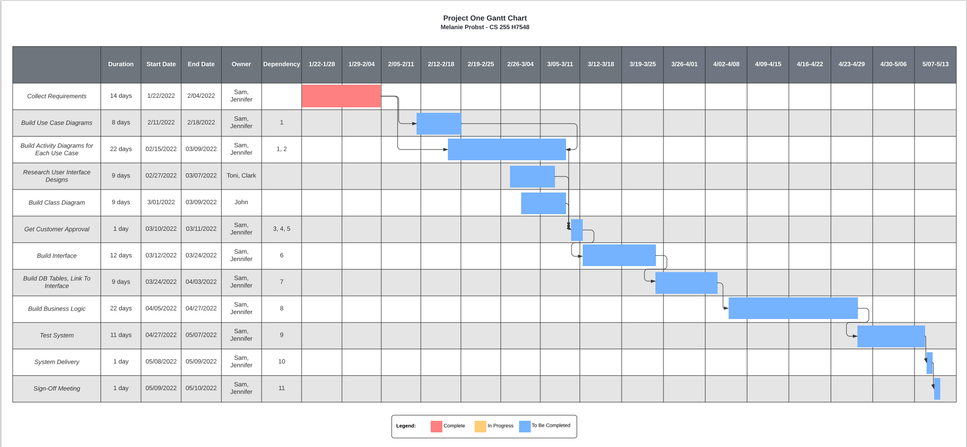

**Sources**

Stefanelli, G. (2022). *CS 255: DriverPass Interview Transcript* [PDF]. SNHU Brightspace. https://learn.snhu.edu